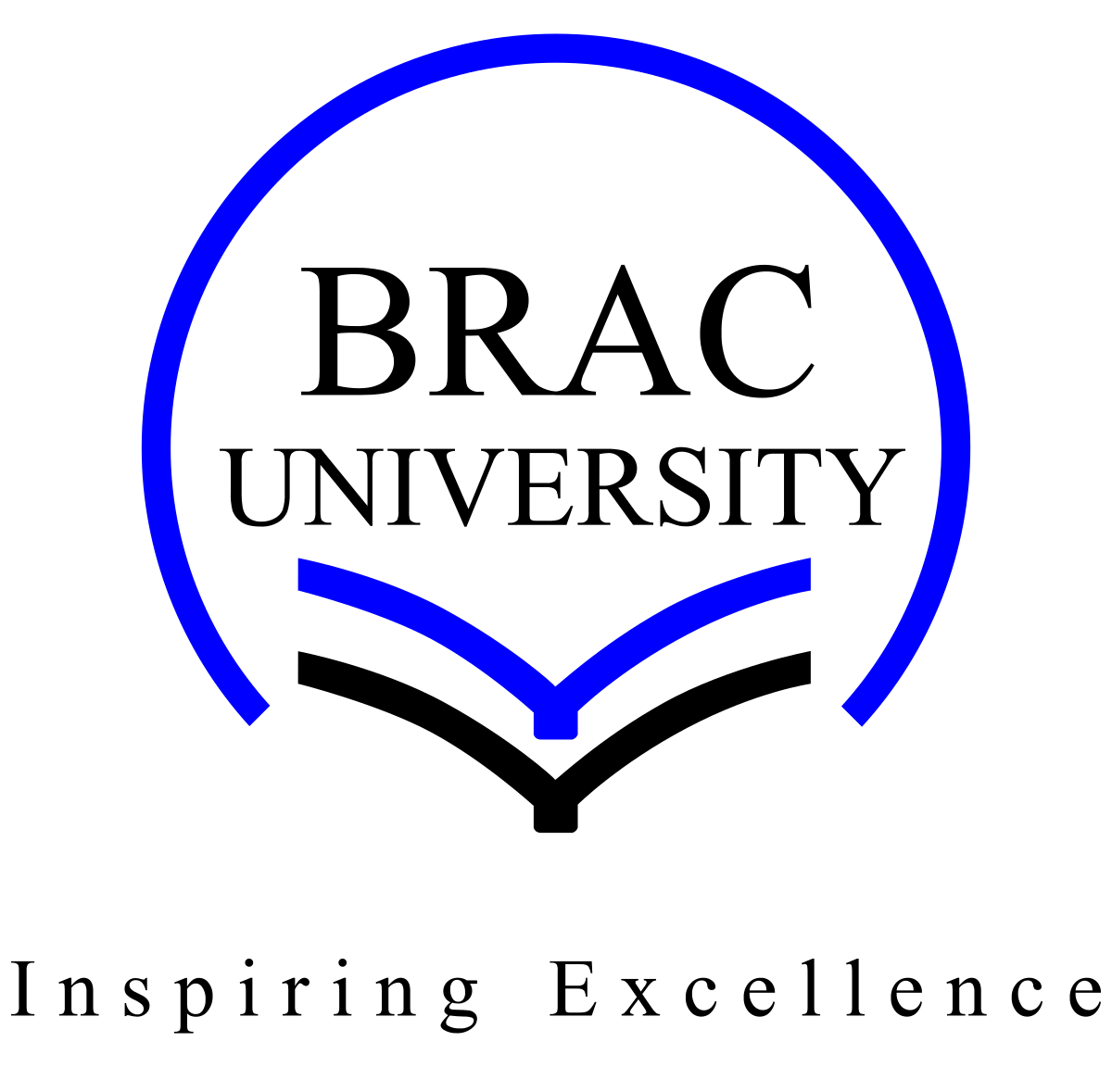
BRAC University (Department of Computer Science and Engineering)
CSE 470 (Software Engineering) | Summer 2025

Quiz 1
Student ID:
Section:19 - Set B Full Marks: 20

Name: Duration: 20 minutes

- Draw and label the Iterative Model. Briefly annotate the key stages. 5

- A small grocery store needs an inventory system.The owner has listed all the required features, and they won’t change.Which model would be the best suited for this? Support your answer with proper logic. 5

3. Short Questions (10 marks)

a. (2 marks) What is meant by the test and validation phase in the V-Model?

b. (2 marks) Write one advantage and one disadvantage of the Evolutionary Model.

c. (2 marks) Name two models where requirements are allowed to evolve.

d. (2 marks) Compare Waterfall and V-Model in terms of testing.

e. (2 marks) Why is the Iterative model suitable for large, complex systems?

